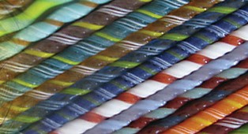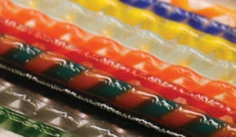The Glass Fusion Collective is an educational nonproﬁt 501(c)(3) formed in 2019 by Hawaii artists working in kiln-formed glass. http://glassfusioncollective.com exhibitfusedglass808@gmail.com
T H E G L A S S F U S I O N C O L L E C T I V E
L E A R N
- T E A C H • C R E A T E
G F C

First Name : Last Name : Address : Address : City: State/Province : Zip/Postal Code : Country :
Phone Number : Email :
PLEASE WRITE THE TITLE, SIZE, METHOD AND PRICE
(ie. Ishibashi - Star 12”w x 8”h - $100)
ARTWORK #1

Title: Size: Method : Price: $
ARTWORK #2

Title: Size: Method : Price: $
ARTWORK #3

Title: Size: Method : Price: $
ARTWORK #4

Title: Size: Method : Price: $
ARTWORK #5

Title: Size: Method : Price: $
LIABILITY & ENTRY AGREEMENT

Neither the Fused Glass Collective nor the Downtown Art Center nor any receiving agent, will be responsible for misrepresentation of an image if a purchase is made. Artist grants permission to GFC & DAC to use images of work in promotional materials and for display in the online exhibition and archive. You are required to sign (via the checkbox below) this waiver for entry acceptance: I hereby agree to the liability agreement and will abide by all rules and stipulations set forth in this Glass Fusion Collective prospectus.*
□ By checking this box you agree to the Liability & Entry Agreement.

